Appendix C: IEEE 830 Template
Software Requirements Specification
for
Your Path

Version v1
Prepared by Mustafa Cilek
04/03/2026
Table of Contents
«Table of Contents»
Revision History
Name | Date | Reason for Changes | Version
Mustafa Cilek | 04/03/2026 | ”Initial version” | V1
Mustafa Cilek | 25/03/2026 | ”Added use case diagrams” | V1.1
Mustafa Cilek | 07/04/2026 | “Added UML Class Diagrams” | V2

1. Introduction
1.1. Purpose
The purpose of this document is to define the requirements for Your Path (v1.0), a platform designed to solve career uncertainty and the lack of verified skill data in recruitment. To address the difficulty students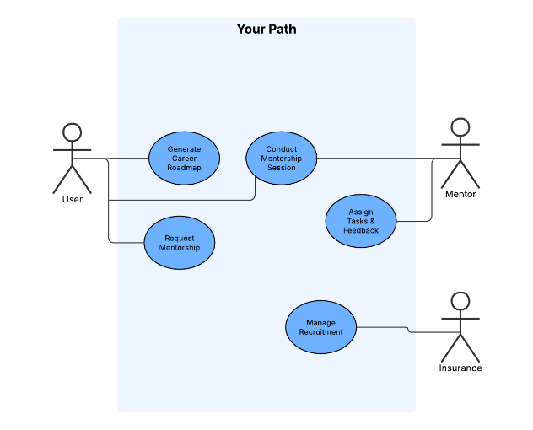 face in aligning their skills with industry needs, the system provides AI-generated personalized roadmaps and structured mentor-matching. By integrating communication tools for guidance and a mentor-led verification system, Your Path replaces uninformed career advice with data-driven insights. This ensures that users receive clear professional direction while HR professionals gain access to reliable, verified evidence of candidate competencies, creating a more efficient and transparent hiring process.
1.2. Document Conventions
«Describe any standards or typographical conventions that were followed when writing this specification, such as fonts or highlighting that have special significance. For example, state whether priorities for higher-level requirements are assumed to be inherited by detailed requirements, or whether every requirement statement is to have its own priority.»
1.3. Intended Audience and Reading Suggestions
«Describe the different types of reader that the document is intended for, such as developers, project managers, marketing staff, users, testers, and documentation writers. Describe what the rest of this document contains and how it is organized. Suggest a sequence for reading the document, beginning with the overview sections and proceeding through the sections that are most pertinent to each reader type.»
1.4. Product Scope
«Provide a short description of the software being specified and its purpose, including relevant benefits, objectives, and goals. Relate the software to corporate goals or business strategies when applicable.»
1.5. References
«List any other documents or Web addresses to which this document refers or was based on. These may include user interface style guides, contracts, standards, system requirements specifications, use case documents, or a vision and scope document. Provide enough information so that the reader could access a copy of each reference, including title, author, version number, date, and source or location. Include the assignment document in the references.»
2. Overall Description
2.1. Product Perspective
«Describe the context and origin of the product being specified in this specification. For example, state whether this product is a follow-on member of a product family, a replacement for certain existing systems, or a new, self-contained product.»
2.2. Product Features
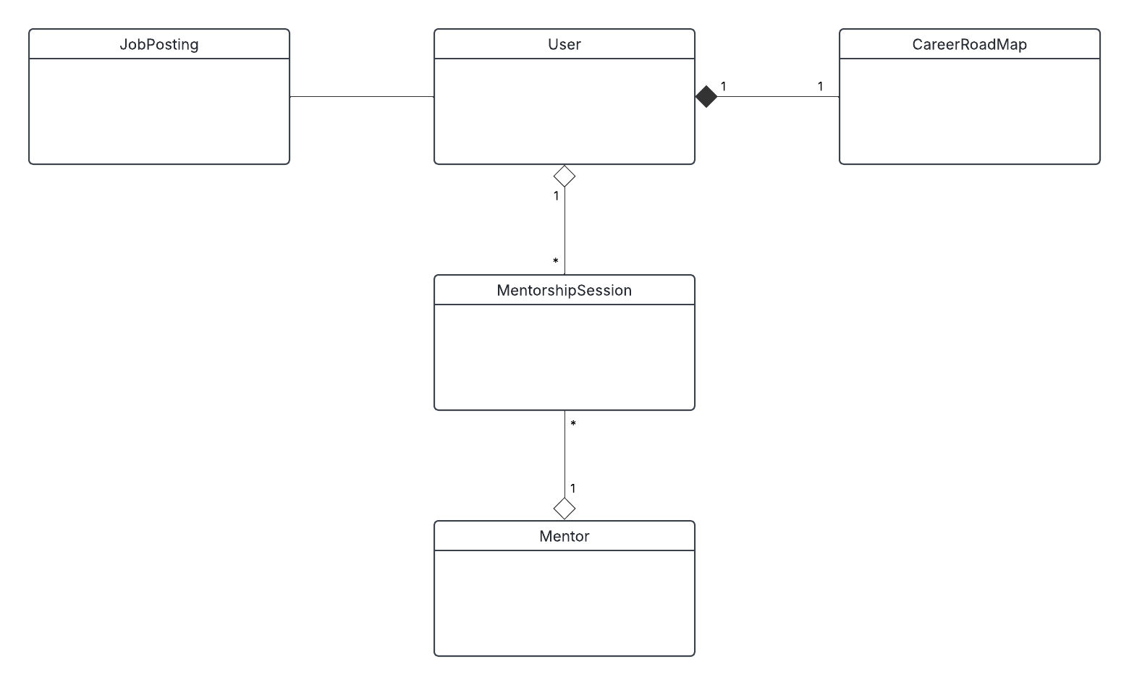

«Summarize the major features the product must perform or must let the user perform. Details will be provided in Section 3, so only a bullet list is needed here. Organize the features to make them understandable to any reader of the specification. A picture of the major groups of related requirements and how they relate, such as a top level data flow diagram or object class diagram, is often effective.»
- «Thing 1»
- «More things as required»
2.3. User Classes and Characteristics
«Identify the various user classes (intended target for the product) that you anticipate will use this product. User classes may be differentiated based on frequency of use, subset of product functions used, technical expertise, security or privilege levels, educational level, or experience. Describe the pertinent characteristics of each user class. Certain requirements may pertain only to certain user classes. Distinguish the most important user classes for this product from those who are less important to satisfy.»
2.4. Operating Environment
«Describe the environment in which the software will operate, including the hardware platform, operating system and versions, and any other software components or applications with which it must peacefully coexist.»
2.5. Design and Implementation Constraints
«Describe any items or issues that will limit the options available to the developers. These might include: corporate or regulatory policies; hardware limitations (timing requirements, memory requirements); interfaces to other applications; specific technologies, tools, and databases to be used; parallel operations; language requirements; communications protocols; security considerations; design conventions or programming standards (for example, if the customer’s organization will be responsible for maintaining the delivered software).»
2.6. User Documentation
«List the user documentation components (such as user manuals, on-line help, and tutorials) that will be delivered along with the software. Identify any known user documentation delivery formats or standards.»
2.7. Assumptions and Dependencies
«List any assumed factors (as opposed to known facts) that could affect the requirements stated in the specification. These could include third-party or commercial components that you plan to use, issues around the development or operating environment, or constraints. The project could be affected if these assumptions are incorrect, are not shared, or change. Also identify any dependencies the project has on external factors, such as software components that you intend to reuse from another project, unless they are already documented elsewhere (for example, in the vision and scope document or the project plan).»
3. System Features
«The purpose here is to give a brief introduction to the system features, so that §4 has something to reference. Then, the full explanation of the system features is given in §5, likely referencing §4. The numbering in §3 and §5 should match.»
3.1. «Feature Name»
«Brief description of the feature, generally 1-3 sentences»
3.«N». «Additional feature blocks as needed»
4. External Interface Requirements
4.1. User Interfaces Overview
«Describe the high level functionality of the system from the user’s perspective. Explain how the user should be able to use your system to complete all the expected features and the feedback information that will be displayed for the user (for each screen the user will see). For example, specify whether it is GUI or text based interface and how at high level it would work. Discuss at high level how user will interact with the game such as clicking buttons, typing in some selection character, etc.»
«Describe the minimum requirements for the interface. This may include some sample screen images whether for text or GUI approach, any GUI standards or product family style guides that are to be followed, screen layout constraints, for GUI standard buttons and functions (e.g., help) that must appear on every screen, keyboard shortcuts, error message display standards, and so on»
4.2. Hardware Interfaces
«Describe the logical and physical characteristics of each interface between the software product and the hardware components of the system. This may include the supported device types, the nature of the data and control interactions between the software and the hardware, and communication protocols to be used.»
4.3. Software Interfaces
«Describe the connections between this product and other specific software components (name and version), including databases, interpreters, operating systems, tools, libraries, and integrated commercial components. Identify the data items or messages coming into the system and going out and describe the purpose of each. Describe the services needed and the nature of communications. Identify data that will be shared across software components. If the data sharing mechanism must be implemented in a specific way (for example, use of a global data area in a multitasking operating system), specify this as an implementation constraint.»
5. System Features/Modules
«This template illustrates organizing the functional requirements for the product by system features, the major services provided by the product.»
5.1. «System Feature Name»
5.1.1 Description and Priority
«Provide a short description of the feature. Give its priority, too.»
5.1.2 Stimulus/Response Sequences
«”Stimulus” or “Condition”»: «Describe the stimulus or condition»
Response: «Describe the response»
«Additional Stimulus/Response pairs as needed»
5.1.3 Functional Requirements
FR-01: The system shall allow users to connect external platforms (LinkedIn, GitHub, Kaggle) to generate AI-based career roadmaps.
FR-02: Users shall be able to search for, view profiles of, and request mentorship from mentors based on expertise.
FR-03: Mentors shall be able to assign weekly tasks, while users track completion and monitor progress via a dashboard.
FR-04: The system shall provide in-app messaging and scheduled video sessions for users and mentors to communicate.
FR-05: HR users shall be able to post jobs, view candidate AI match scores, and move applicants through recruitment stages (e.g., interview, offer).
6. Nonfunctional Requirements
6.1. Performance
NF-1.1: The system shall load the user dashboard and career roadmap within 2 seconds under normal network conditions.
NF-1.2: The platform must support at least 1,000 concurrent video sessions without degradation in audio or video quality.
6.2. Security
NF-2.1: All user data, including integrated profile data from LinkedIn or GitHub, must be encrypted at rest and in transit using AES-256.
NF-2.2: The system shall use Two-Factor Authentication (2FA) for all HR and Mentor accounts to protect sensitive recruitment and personal data.

